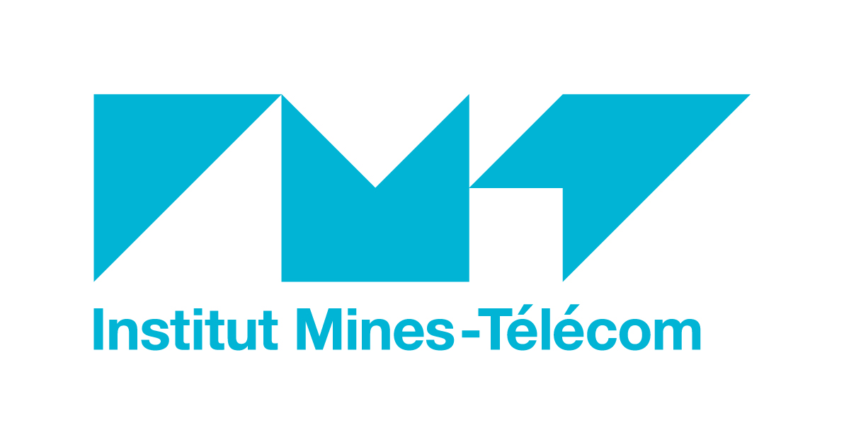 | 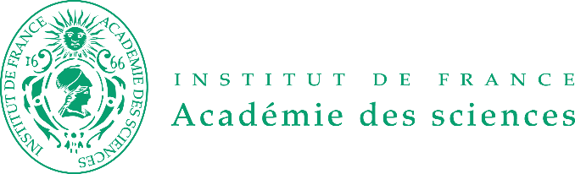
Paris, 31 January
Press release

Research

> The IMT-Académie des Sciences Awards 2019 open for applications
The third edition of the IMT-Académie des Sciences Awards is now open for applications. Supported by Fondation Mines-Télécom, the awards strive to reward exceptional scientific contributions at the European level in three areas: digital transformation in industry; energy and environmental engineering; and materials and manufacturing (new for 2019). The deadline for applications is April 23, 2019.

Two prizes  The IMT-Académie des sciences awards comprise two prizes:  - a Grand Prix awarded to a scientist who has made an exceptional contribution to the fields mentioned above through an outstanding body of work;  - a Young Scientist Prize awarded to a scientist who is under 40 years old on January 1st of the year the prize is awarded, and who has contributed to these same fields with a major innovation. | 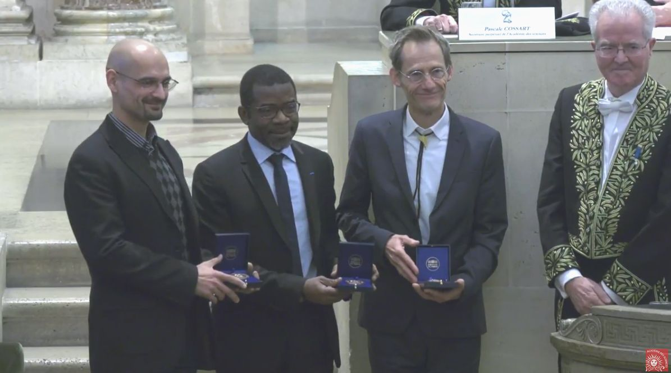  2018 Awards Ceremony  At the Académie des Sciences
These prizes will be awarded by IMT, with support from Fondation Mines-Télécom and the Académie des Sciences. They will include the following prize amounts:
- Grand Prix: €30,000
- Young Scientist Prize: €15,000

Each prize will be awarded to a scientist of any nationality working in France, or in Europe in close collaboration with French teams. Applications must be sent to the Académie des Sciences by a laboratory director, an establishment manager or a member of the Académie who supports the application.

Official awards ceremony in the dome of the Institut de France
The formal awards ceremony will be held in the dome of the Institut de France in fall 2019. It will be accompanied by a ceremony at the Académie des Sciences by IMT for the winners to present their works.

Submit an application before April 23, 2019

See the winners of the 2018 and 2017 editions: Pierre Comon (CNRS-Université Grenoble Alpes, Grenoble INP), Ange Nzihou (IMT Mines Albi), Ioan-Mihai Miron (CNRS-CEA), Sébastien Bigo (Nokia Bell Labs), Pierre Rouchon (Mines ParisTech), Julien Bras (Université Grenoble Alpes-Grenoble INP).

About IMT www.imt.fr
Institut Mines-Télécom is a public institution dedicated to higher education, research and innovation in engineering and digital technology Always attentive to the economic world, IMT combines academic and scientific legitimacy with strong corporate relationships and a unique focus on the key transformations in digital technology, industry, energy and education in the 21st century. Its activities are conducted in Mines and Télécom graduate schools under the authority of the Ministry of Industry and Electronic Communications, a subsidiary, and associate schools or schools under contractual agreements. IMT is a founding member of the Alliance Industrie du Futur. It has two Carnot Institute accreditations for its high-quality research partnerships. Every year, around 100 start-ups come out of its incubators.

Press contacts  Agence OXYGEN  Cécile Mathey / Tatiana Grafeuill  +33 (0)1 41 11 35 41 / +33 (0)1 41 11 37 89  cecilem@oxygen-rp.com / tgraffeuil@oxygen-rp.com / | IMT  Jérôme Vauselle  +33 (0)1 45 81 75 05  jerome.vauselle@imt.fr

